Patient Details
Surname: ____________________________ Given names: __________________________ Title_________ Preferred name: ______________________ DOB: _____/_______/_______
Address: ___________________________________________________________________ Suburb: _____________________________ State:_______________ Postcode: __________ P.O. BOX: __________ Suburb : __________State: ______________ Postcode: __________ Phone : (M) ____________________ (H) ___________________ (W)__________________ Email:______________________________________________________________________ Emergency Contact Name : ____________________________________________________
Phone : _______________________________ Relationship: _________________________
Medicare No: ____________________________________ Ref: ______ Exp: _____/______ Pension/Health Care card No: _________________________ Exp: ______/______/______ Veteran Affairs No: ______________________________ Gold or White Card
Does Medicare have your bank details? (Pls circle) YES - NO
** IF NO - Please provide your bank details so your rebate can be transferred
Bank : ______________________ ACC Name: ____________________________________ ACC No: _____________________________________ BSB: _________________________
Occupation ________________________________________________________________
As a patient of Northern Skin Doctors, we require you to provide us with your personal details and medical history, to aid us in properly assessing, diagnosing & treating your skin.
We aim to protect your privacy and have secure storage of your health information.
We require your consent to collect personal information about you and to use the information you provide for Medicare Billing, HIC requirements, administration and quality improvement for our practice.
Northern Skin Doctors routinely sends SMS messages which act as a reminder for clinical review, appointments and clinical/health awareness.
If you do NOT wish to have reminders sent, please advise our reception/nursing staff
Assessment and Analysis (the following questions will assist with today's assessment)
Medical Conditions Suffered: ___________________________________________________
Allergies: ____________________________________________________________________ Current Medications/Blood Thinners: ______________________________________________
Do you have a family history of melanoma Y / N
Have you previously had any Skin Cancer treatment? Y / N
Do you have a Heart Pacemaker/Defibrillator? Y / N
Do you have a Cochlear Implant? Y / N
Do you have a Transmissible Infection? Y / N
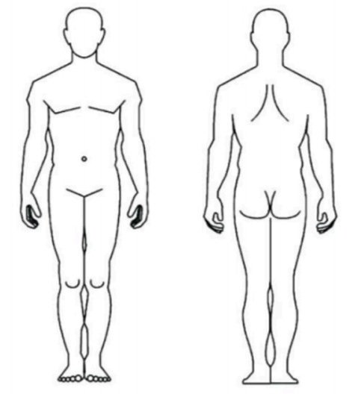
Please write any concerns with your skin or place a X on any area of concern: _____________ ____________________________________________________________________________

- I have read the information on this sheet and understand the reasons why my information must be collected.
- I understand that I am not obliged to provide any information requested of me, but failure to do so may compromise the quality of health care and treatment given to me.
- I am aware of my rights to access the information collected about myself. If my information is to be used for any other purpose other than set out above, my further consent will be obtained.
- I consent to the handling of my information by the practice for the purpose set out above, subject to any limitations which I will discuss with the doctor.
Signature: _____________________________________ Date: _______/_______/_______

